A Theory of Coteries: Mutual Exclusion in Distributed Systems

Toshihide Ibraki and Tiko Lameda
IEEE TRANSACTIONS ON PARREL AND DISTRIBUTED SYSTEMS, VOL. 4, NO. 7, JULY 1993 pp.779-793
Abstract
In this paper, we characterize the ND as exactly those families which can be represented by positive, self-dual functions.
1.Introduction
Basic Results
1.C is an ND coterie iff f_{C} is self-dual.
².C is a coterie iff f_{C} is dual-minor (f ≤ fd)
³.The number of ND coteries under U is equal to the number of positive, self-dual Boolean functions of n variables.
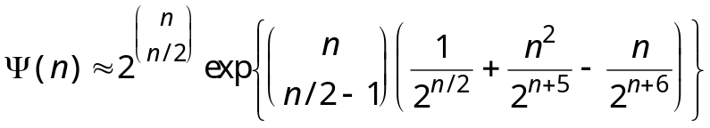

a lower bound 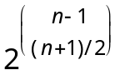
Construction of ND Coteries from Coteries

f=xf_{x=1}∨f_{x=0}

<<<<<<<<<<<to be continued………………
Created by : Kwo-Tsung Tseng
Date : August 21, 1998

